**Predicting House Price Using Machine Learning Model**

Algorithm Code:

import pandas as pd

import numpy as np

from sklearn.linear_model import LinearRegression

from sklearn.tree import DecisionTreeRegressor

from sklearn.ensemble import RandomForestRegressor

from sklearn.metrics import mean_squared_error, r2_score

from sklearn.preprocessing import OneHotEncoder

from sklearn.compose import ColumnTransformer

from sklearn.pipeline import Pipeline

# Load training and test data

train_data = pd.read_csv('train.csv') # Training data file

test_data = pd.read_csv('test.csv') # Test data file

# Separate features (X) and target (y) for training data

X_train = train_data[['num_rooms', 'sqft', 'neighborhood', 'other_features', 'proximity_to_city']]

y_train = train_data['price']

# Separate features (X) and target (y) for test data

X_test = test_data[['num_rooms', 'sqft', 'neighborhood', 'other_features', 'proximity_to_city']]

y_test = test_data['price']

# Preprocessing pipeline for categorical features

preprocessor = ColumnTransformer(

transformers=[

('cat', OneHotEncoder(drop='first'), ['neighborhood', 'other_features'])

],

remainder='passthrough' # Leave other features (like num_rooms, sqft, proximity_to_city) as they are

)

# Function to evaluate models

def evaluate_model(model, X_train, X_test, y_train, y_test):

# Fit the model

model.fit(X_train, y_train)

# Make predictions

y_pred = model.predict(X_test)

# Calculate evaluation metrics

mse = mean_squared_error(y_test, y_pred)

r2 = r2_score(y_test, y_pred)

return mse, r2

# Dictionary to store results

results = {}

# Linear Regression

lr_pipeline = Pipeline(steps=[

('preprocessor', preprocessor),

('model', LinearRegression())

])

mse, r2 = evaluate_model(lr_pipeline, X_train, X_test, y_train, y_test)

results['Linear Regression'] = {'MSE': mse, 'R2': r2}

# Decision Tree

dt_pipeline = Pipeline(steps=[

('preprocessor', preprocessor),

('model', DecisionTreeRegressor(random_state=42))

])

mse, r2 = evaluate_model(dt_pipeline, X_train, X_test, y_train, y_test)

results['Decision Tree'] = {'MSE': mse, 'R2': r2}

# Random Forest

rf_pipeline = Pipeline(steps=[

('preprocessor', preprocessor),

('model', RandomForestRegressor(random_state=42))

])

mse, r2 = evaluate_model(rf_pipeline, X_train, X_test, y_train, y_test)

results['Random Forest'] = {'MSE': mse, 'R2': r2}

# Display results

for model_name, metrics in results.items():

print(f"{model_name} - MSE: {metrics['MSE']:.2f}, R2: {metrics['R2']:.2f}")

# predictioin

new_house_data = pd.DataFrame({

'num_rooms': [5], # Number of rooms

'sqft': [3375], # Square footage

'neighborhood': ['Rural'], # Neighborhood type (Urban or Rural)

'other_features': ['No Garage'], # Garage feature (Has Garage or No Garage)

'proximity_to_city': [31] # Proximity to city (numeric value)

})

predicted_price = rf_pipeline.predict(new_house_data)

# Output the prediction

print("")

print(f"Predicted price for the new house: ${predicted_price[0]:,.2f}")

Output:

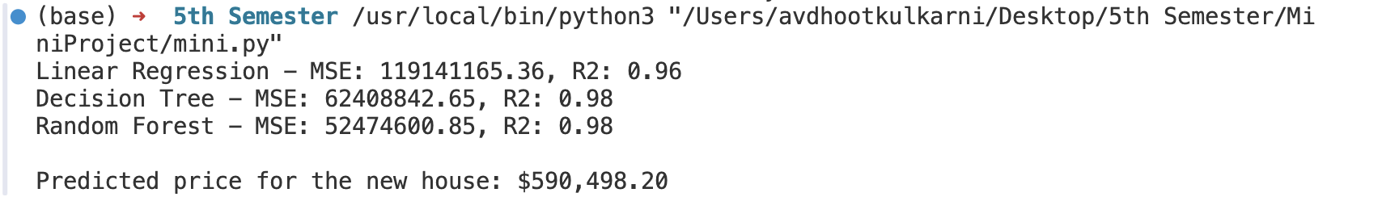

This is the output based on the input given above in the code, this input can be changed.

# predictioin

new_house_data = pd.DataFrame({

'num_rooms': [5], # Number of rooms

'sqft': [3375], # Square footage

'neighborhood': ['Rural'], # Neighborhood type (Urban or Rural)

'other_features': ['No Garage'], # Garage feature (Has Garage or No Garage)

'proximity_to_city': [31] # Proximity to city (numeric value)

})

Based on different inputs required by the client, we can predict the House Price.